Ruler
# Source: AI Source: Provided by: [Data Path: Persons Table -> ID Column: 1, Name_En Column: Motasem Essam] -> From: [ChatGPT] on [7/17/2026]
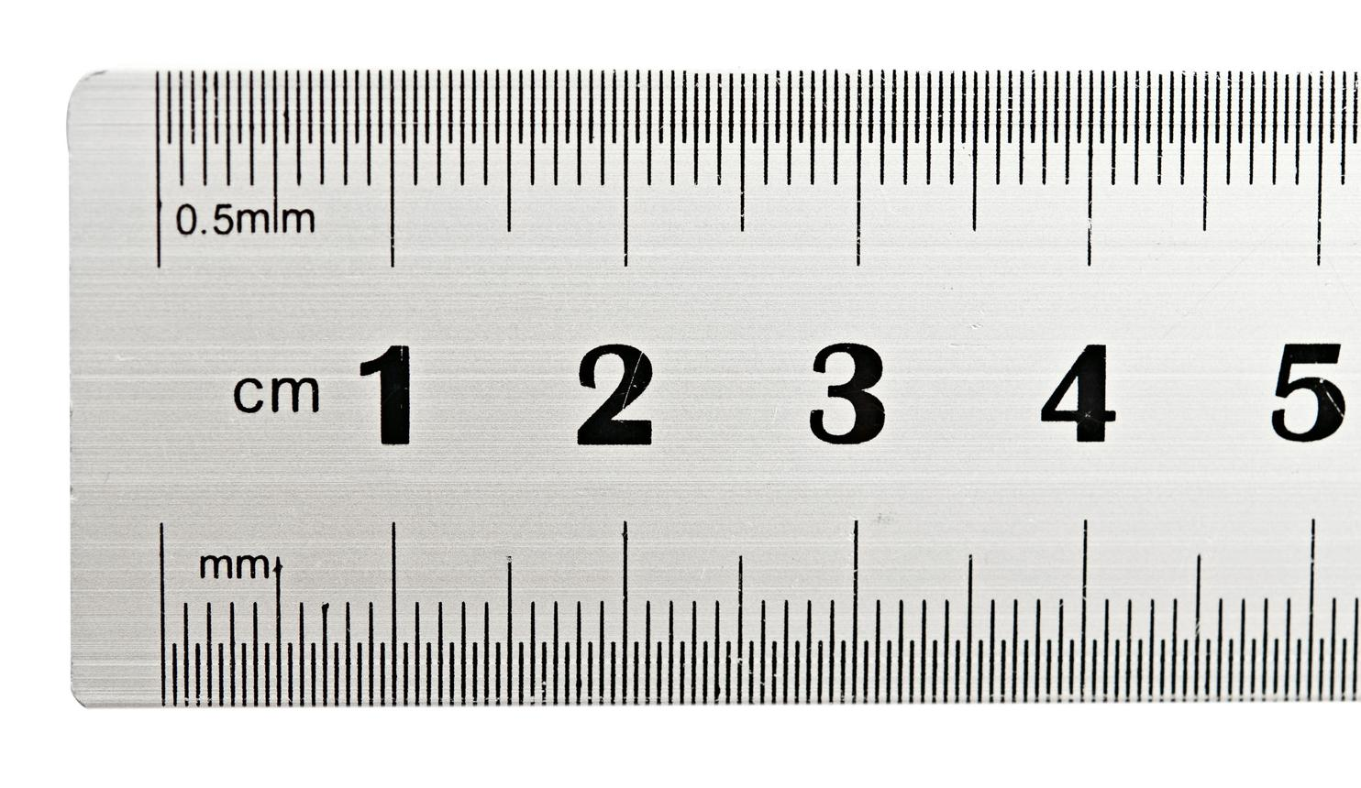
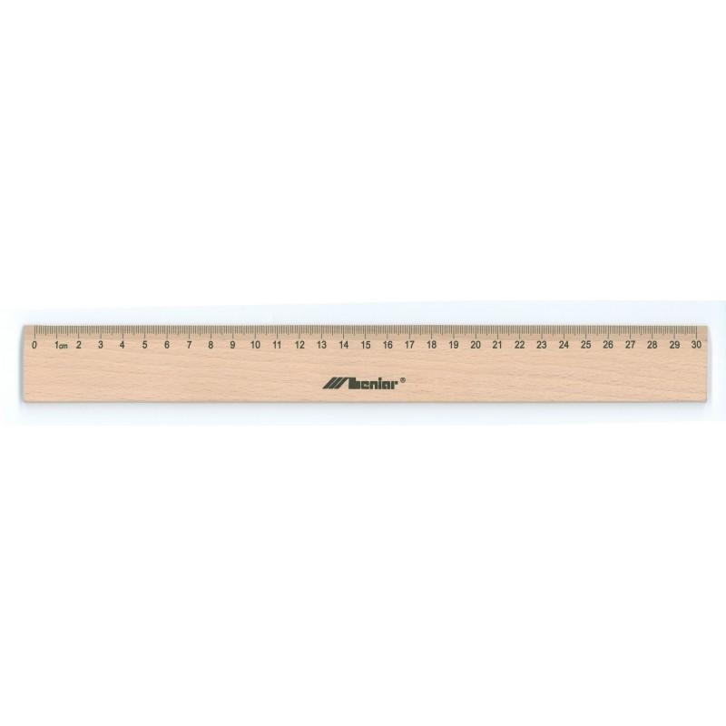
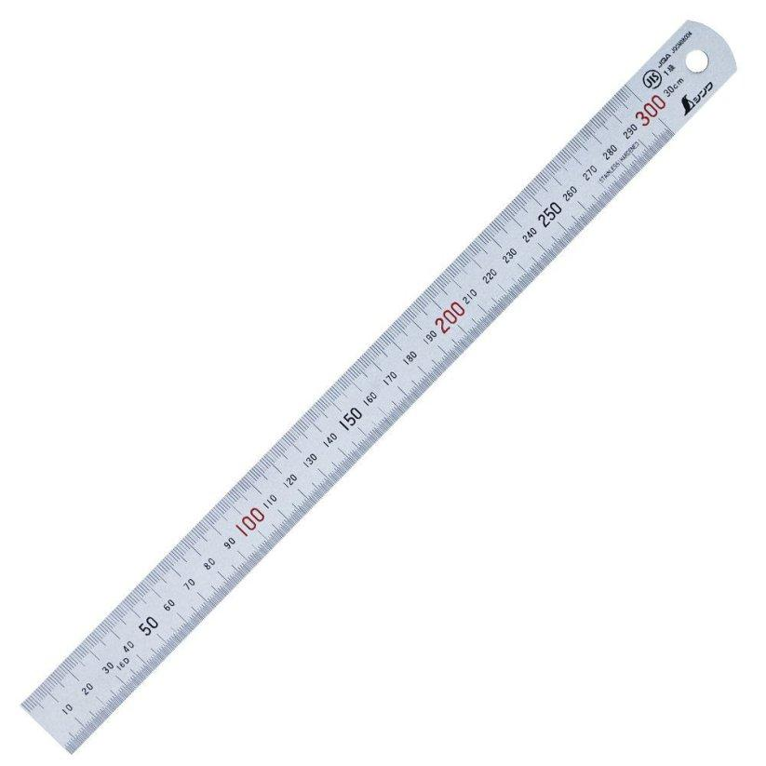
A Ruler is a straight measuring instrument used to measure length, width, height, thickness, and short distances. It is one of the simplest and most widely used measuring tools in education, engineering, drafting, construction, manufacturing, and everyday activities.
Rulers are marked with a graduated scale, typically in the Metric System (millimeters and centimeters), the Imperial System (inches), or both.

Definition
# Source: AI Source: Provided by: [Data Path: Persons Table -> ID Column: 1, Name_En Column: Motasem Essam] -> From: [ChatGPT] on [7/17/2026]
A ruler is a straight measuring instrument with graduated markings used to measure linear dimensions and draw straight lines.

Purpose
# Source: AI Source: Provided by: [Data Path: Persons Table -> ID Column: 1, Name_En Column: Motasem Essam] -> From: [ChatGPT] on [7/17/2026]
A ruler is used to:
- Measure length.
- Measure width.
- Measure height.
- Measure thickness.
- Draw straight lines.
- Mark distances.
- Assist in technical drawing.
- Perform simple layout work.

Construction
# Source: AI Source: Provided by: [Data Path: Persons Table -> ID Column: 1, Name_En Column: Motasem Essam] -> From: [ChatGPT] on [7/17/2026]
A typical ruler consists of:
- Straight edge
- Graduated scale
- Zero reference mark
- Measurement markings
- End edge

Common Materials
# Source: AI Source: Provided by: [Data Path: Persons Table -> ID Column: 1, Name_En Column: Motasem Essam] -> From: [ChatGPT] on [7/17/2026]
Rulers may be made from:
- Plastic
- Wood
- Stainless steel
- Aluminum
- Acrylic

Common Lengths
# Source: AI Source: Provided by: [Data Path: Persons Table -> ID Column: 1, Name_En Column: Motasem Essam] -> From: [ChatGPT] on [7/17/2026]
Typical ruler sizes include:
- 15 cm
- 20 cm
- 30 cm
- 50 cm
- 100 cm (meter rule)

Measurement Units
# Source: AI Source: Provided by: [Data Path: Persons Table -> ID Column: 1, Name_En Column: Motasem Essam] -> From: [ChatGPT] on [7/17/2026]
A ruler may display one or both of the following systems.
Metric Scale
Uses:
- Millimeters (mm)
- Centimeters (cm)
Typical graduations:
- 1 cm = 10 mm

Imperial Scale
# Source: AI Source: Provided by: [Data Path: Persons Table -> ID Column: 1, Name_En Column: Motasem Essam] -> From: [ChatGPT] on [7/17/2026]
Uses:
- Inches (in)
Typical subdivisions:
- 1/2 inch
- 1/4 inch
- 1/8 inch
- 1/16 inch

Measuring Range
# Source: AI Source: Provided by: [Data Path: Persons Table -> ID Column: 1, Name_En Column: Motasem Essam] -> From: [ChatGPT] on [7/17/2026]
The measuring range depends on the ruler length.
Examples:
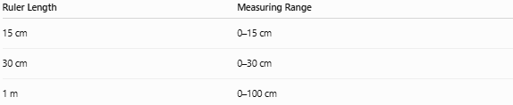
Ruler Length | Measuring Range
15 cm | 0–15 cm
30 cm | 0–30 cm
1 m | 0–100 cm

Least Count (Resolution)
# Source: AI Source: Provided by: [Data Path: Persons Table -> ID Column: 1, Name_En Column: Motasem Essam] -> From: [ChatGPT] on [7/17/2026]
The least count is the smallest division that can be read.
Typical values:
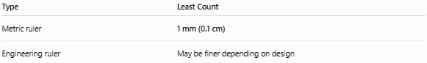
Type | Least Count
Metric ruler | 1 mm (0.1 cm)
Engineering ruler | May be finer depending on design

How to Measure with a Ruler
# Source: AI Source: Provided by: [Data Path: Persons Table -> ID Column: 1, Name_En Column: Motasem Essam] -> From: [ChatGPT] on [7/17/2026]
- Place the ruler parallel to the object.
- Align the zero mark with one end of the object.
- Ensure the ruler lies flat.
- Read the graduation at the opposite end.
- Record the measurement with the correct unit.

Example
# Source: AI Source: Provided by: [Data Path: Persons Table -> ID Column: 1, Name_En Column: Motasem Essam] -> From: [ChatGPT] on [7/17/2026]
Suppose an object's end aligns with the 7.6 cm mark.
The measured length is:
7.6 cm
or
76 mm

Accuracy
# Source: AI Source: Provided by: [Data Path: Persons Table -> ID Column: 1, Name_En Column: Motasem Essam] -> From: [ChatGPT] on [7/17/2026]
A standard ruler typically provides measurements accurate to approximately ±0.5 mm, depending on:
- Manufacturing quality
- User technique
- Viewing angle (parallax)
- Condition of the ruler

Sources of Error
# Source: AI Source: Provided by: [Data Path: Persons Table -> ID Column: 1, Name_En Column: Motasem Essam] -> From: [ChatGPT] on [7/17/2026]
Common measurement errors include:
Instrument Errors
- Worn or damaged edges
- Faded graduations
- Manufacturing defects

Observation Errors
# Source: AI Source: Provided by: [Data Path: Persons Table -> ID Column: 1, Name_En Column: Motasem Essam] -> From: [ChatGPT] on [7/17/2026]
- Parallax error
- Reading the wrong graduation
- Estimation errors

Positioning Errors
# Source: AI Source: Provided by: [Data Path: Persons Table -> ID Column: 1, Name_En Column: Motasem Essam] -> From: [ChatGPT] on [7/17/2026]
- Misaligned zero mark
- Tilted ruler
- Measuring from the ruler's edge instead of the zero mark (especially if the edge is worn)

Environmental Errors
# Source: AI Source: Provided by: [Data Path: Persons Table -> ID Column: 1, Name_En Column: Motasem Essam] -> From: [ChatGPT] on [7/17/2026]
- Expansion due to temperature (mainly metal rulers)
- Dirt or debris between the ruler and the object

Applications
# Source: AI Source: Provided by: [Data Path: Persons Table -> ID Column: 1, Name_En Column: Motasem Essam] -> From: [ChatGPT] on [7/17/2026]
Rulers are used in:
- Schools
- Mathematics
- Engineering
- Technical drawing
- Architecture
- Construction
- Manufacturing
- Woodworking
- Crafting
- Laboratories

Advantages
# Source: AI Source: Provided by: [Data Path: Persons Table -> ID Column: 1, Name_En Column: Motasem Essam] -> From: [ChatGPT] on [7/17/2026]
A ruler:
- Is inexpensive.
- Is easy to use.
- Is portable.
- Requires no power.
- Is suitable for quick measurements.
- Can also be used as a straightedge.

Limitations
# Source: AI Source: Provided by: [Data Path: Persons Table -> ID Column: 1, Name_En Column: Motasem Essam] -> From: [ChatGPT] on [7/17/2026]
A ruler:
- Has limited precision compared with instruments such as calipers or micrometers.
- Is unsuitable for measuring curved surfaces accurately.
- Cannot measure internal diameters or depths.
- May produce reading errors due to parallax.

Comparison with Other Length Measuring Instruments
# Source: AI Source: Provided by: [Data Path: Persons Table -> ID Column: 1, Name_En Column: Motasem Essam] -> From: [ChatGPT] on [7/17/2026]
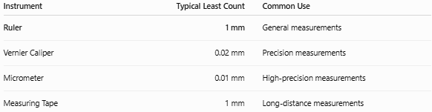
Instrument | Typical Least Count | Common Use
Ruler | 1 mm | General measurements
Vernier Caliper | 0.02 mm | Precision measurements
Micrometer | 0.01 mm | High-precision measurements
Measuring Tape | 1 mm | Long-distance measurements

Care and Maintenance
# Source: AI Source: Provided by: [Data Path: Persons Table -> ID Column: 1, Name_En Column: Motasem Essam] -> From: [ChatGPT] on [7/17/2026]
To maintain accuracy:
- Keep the ruler clean.
- Avoid bending or twisting it.
- Store it flat.
- Protect the graduations from wear.
- Replace damaged rulers.

Key Points
# Source: AI Source: Provided by: [Data Path: Persons Table -> ID Column: 1, Name_En Column: Motasem Essam] -> From: [ChatGPT] on [7/17/2026]
- A ruler is a straight measuring instrument for measuring linear dimensions.
- It commonly uses millimeters, centimeters, and inches.
- Typical least count is 1 mm.
- It is suitable for general-purpose length measurements.
- Proper alignment with the zero mark is essential for accurate results.

Conclusion
# Source: AI Source: Provided by: [Data Path: Persons Table -> ID Column: 1, Name_En Column: Motasem Essam] -> From: [ChatGPT] on [7/17/2026]
A ruler is one of the most fundamental measuring instruments used for determining length and other linear dimensions. With its simple graduated scale, it provides quick and convenient measurements in both metric and imperial units. Although it offers lower precision than instruments such as Vernier calipers or micrometers, its ease of use, portability, and versatility make it indispensable in education, engineering, drafting, construction, and everyday measurement tasks.

